**HERE IT CONTAINS EACH STEPS OF TASK 1**

**TASK 1 : Creating a Git Repository**

**1. Create a GitHub Repository**

**Go to GitHub and sign in.**

**Click on "New Repository" and name it as your enrollment number.**

**Set it to "Public" or "Private" as required.**

**Click "Create Repository."**

**2. Clone the Repository Locally**

**Open Git Bash or Terminal.**

**Run:**

**git clone https://github.com/your-username/your-enrollment-number.git**

**cd your-enrollment-number**

**3. Create Folders for Assignments**

**Inside the cloned repository folder, run:**

**mkdir Assignment_1 Assignment_2**

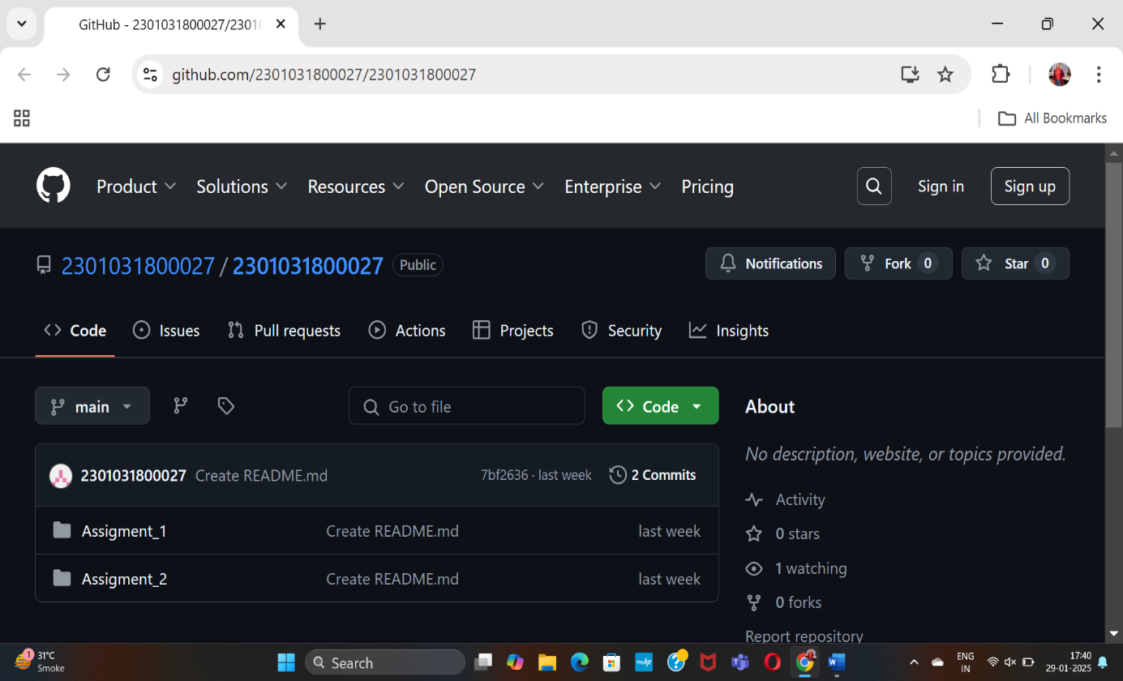

Above is the Screenshot of Git repository

--------------------------------